1

Self Service for Faculty
Version 1.0 | February 2022

Table of Contents
Faculty 3
How to access Self Service 4
Faculty Overview Page 4
Faculty Overview Page Features 4
Registration Permissions 5
Grading 6
Advising Overview Page 8
Advising Overview Page Features 8
Overview of Advising Tabs 10

Faculty
Welcome to Rush University’s Self Service guide for faculty and advisors! Rush University is replacing Web Advisor with the Self Service system, a next-generation platform from Ellucian (Colleague).
The Self Service System allows faculty and advisors to do the following:
Faculty | Advisors
- Manage your course(s) by section  - View your roster(s)  - Grant permissions  - Assign final grades | - Review course plans for a particular term under the Course Plan tab  - Review a students’ timeline by past, current, and future terms in the Timeline tab  - Review the degree audit for the student under the Progress tab  - Compose a note to the student and review a history of notes between student and advisor in the Notes tab  - Review PDF archives of student plans in the Plan Archive tab  - View, download, and/or print an unofficial transcript from the Unofficial Transcript tab  - Review grades & credits by term in the Grades tab  - View petitions and waivers in the Petitions and Waivers tab  - View intent to graduate submissions in the Graduation tab.

All faculty and advisors should begin using Self Service by Spring 2022, WebAdvisor will be phased out by Summer 2022.

How to access Self Service

- To access Self Service, go to: https://rush.sharepoint.com/sites/university and log in using your Rush University username and password.
- Select “Self Service from the Rush University portal.
- You may be directed to the address page. You can ignore this by selecting the home button then selecting “Faculty” or “Advising”.

Faculty Overview Page

Faculty Overview Page Features

- From the faculty menu, you can view course rosters, submit grades, and more. Your courses will be listed by section. Select a course to view the section details.
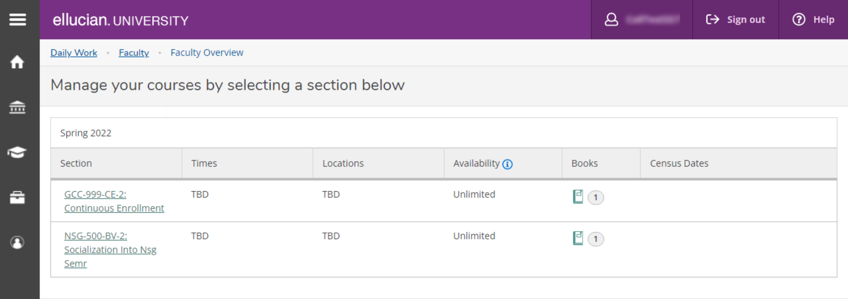
- By selecting the course roster, you will be able to view all actively enrolled students.
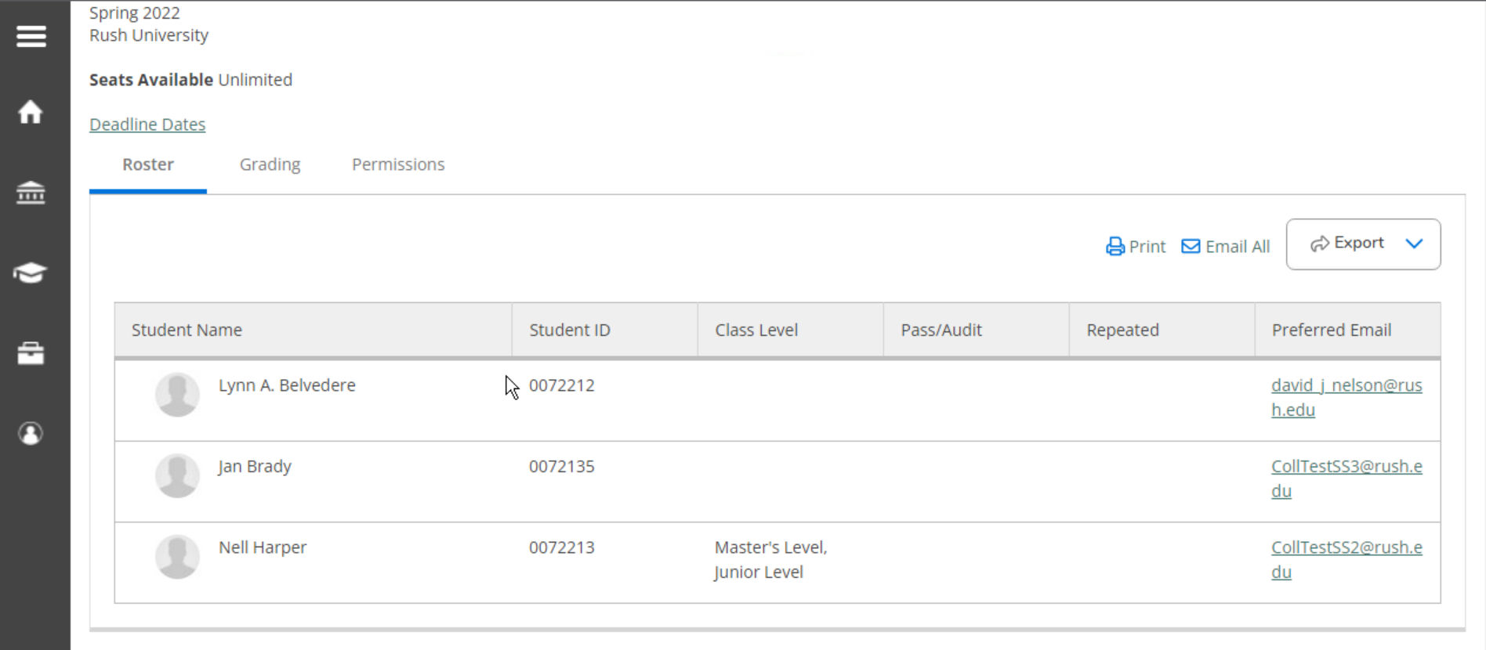

- Additional features include options to print your roster (1), email all enrolled students (2), and download the roster as a .csv file (3).
2
3
1

Registration Permissions

- To add a registration permission, select Permissions and Waivers tab, then the button for the type of permission you would like to add. In this demonstration, we will select the “Faculty Consent” button. But the steps would be similar to waive a requisite for a student.
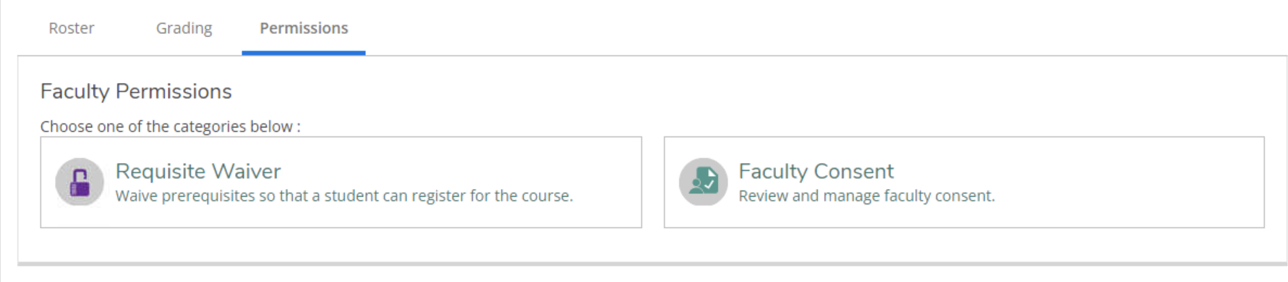
- You can search for the student for whom you would like to add the consent by ID or last comma first in the search box on the right.
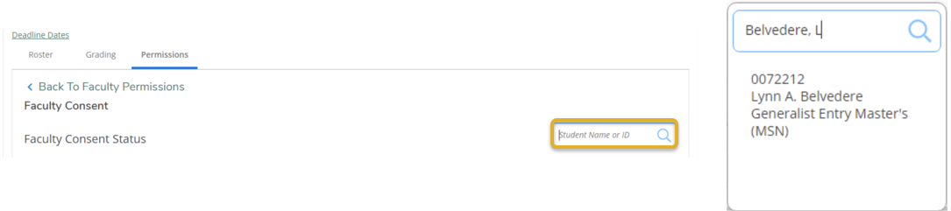
- After selecting the appropriate student, a window will pop up. Add a status of “Approved” from the drop-down menu (1). You must enter a reason for the approval (2). Then, save the record (3). You will now see the consent you’ve just added, listed under Faculty Consent Status. The student will also see this permission when they access their record in Student Planning.
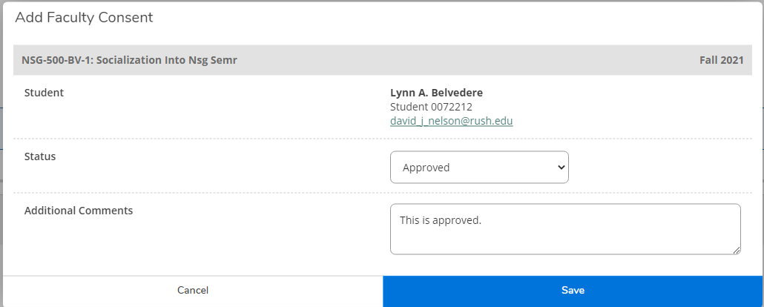
3
2
1

Grading

- When the grading period is open, you will be able to add grades through the grading tab.

- Be sure that you are on the “Final Grade” tab. Enter a final grade from the drop-down menu for every student on the roster.
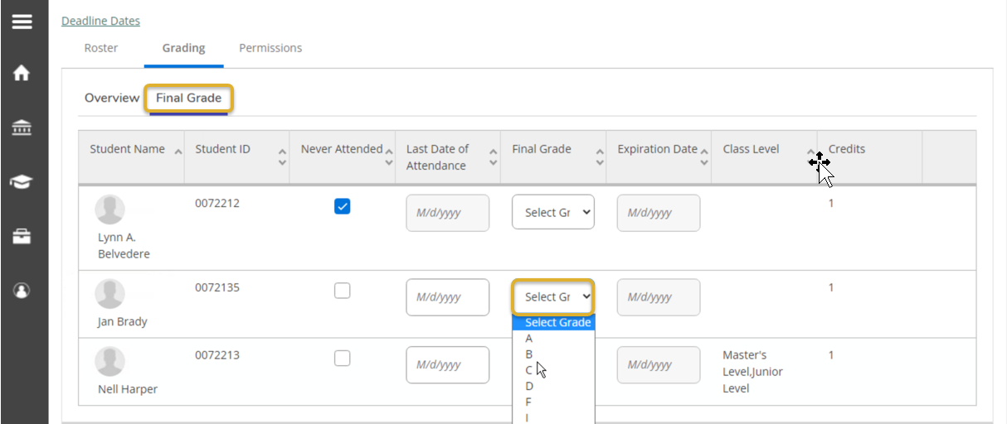

- For students who never attended the course, select the “Never Attended” box. For students who will be getting an incomplete in the course, enter a grade of “I” and an expiration date.

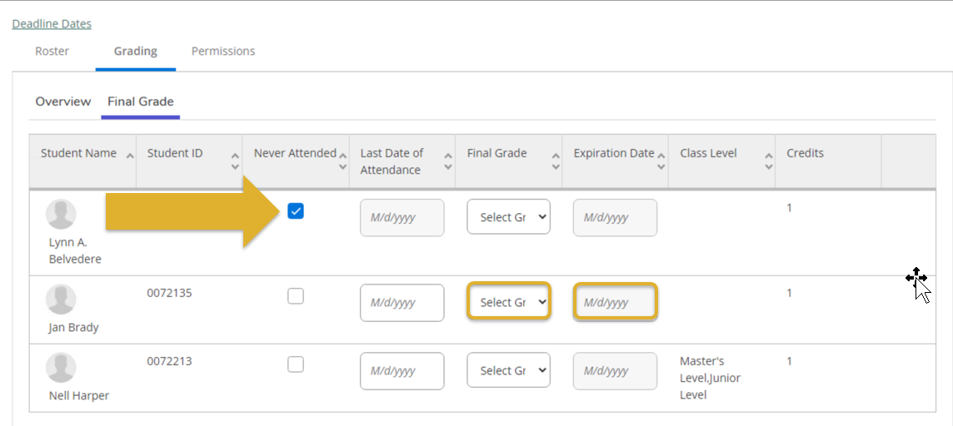
Please note: There is no submit button when you are entering final grades, but the system is saving your entries. When you tab off of the final grades tab, you will see the grades listed next to each student on the summary tab.

Advising Overview Page

Advising Overview Page Features

- Your advisees will be listed on the Advising Overview page. You can search for an advisee by using the search bar above. Be sure to select the radio button for student when searching for an advisee. You can search by an advisee’s name (in the format last comma first) or by their student ID number.

- The Advising Overview page lists each advisee’s name, whether they have requested a review, their student ID, their program or programs of study, their advisors, and the option to view details for each student.
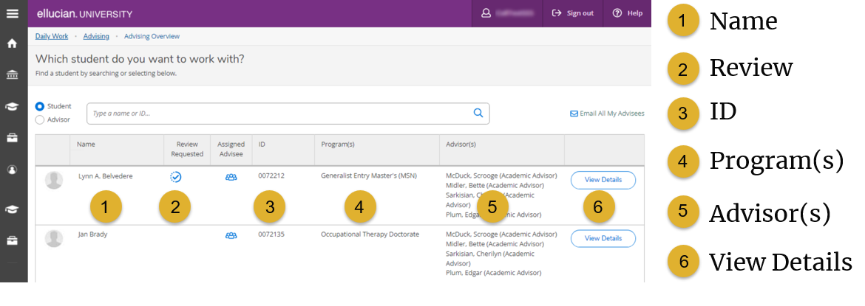
- Selecting an advisee’s name will take you to the advising screen for that student. From this page you can complete a requested review and see a course plan history. Your advisee may request that you review their planned coursework for accuracy. Selecting the “Review Complete” button will complete that review.
If an advisee requests a review, their advisor will receive an automated email indicating that a review has been requested.

In addition, from this screen an advisor can use various tabs do the following:
- Review course plans for a particular term under the Course Plan tab
- Review a student’s timeline by past, current, and future terms in the Timeline tab
- Review the degree audit for the student under the Progress tab
- Search for courses in the Course Catalog tab
- Compose a note to the student and review a history of notes between student and advisor in the Notes tab
- Review PDF archives of student plans in the Plan Archive tab
- View, download, and/or print an unofficial transcript from the Unofficial Transcript tab
- Review grades & credits by term in the Grades tab
- View petitions and waivers in the Petitions and Waivers tab
- View petition for graduation in the Graduation tab.
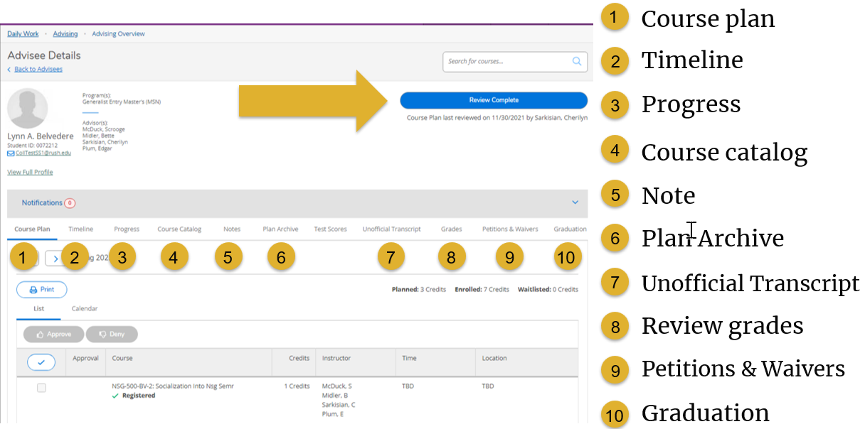
Note: the “Test Scores” tab will not have any data in it. Rush University does import admission test scores into Colleague.

Overview of Advising Tabs

- The Course Plan tab displays an advisee’s schedule in a list view and calendar view.
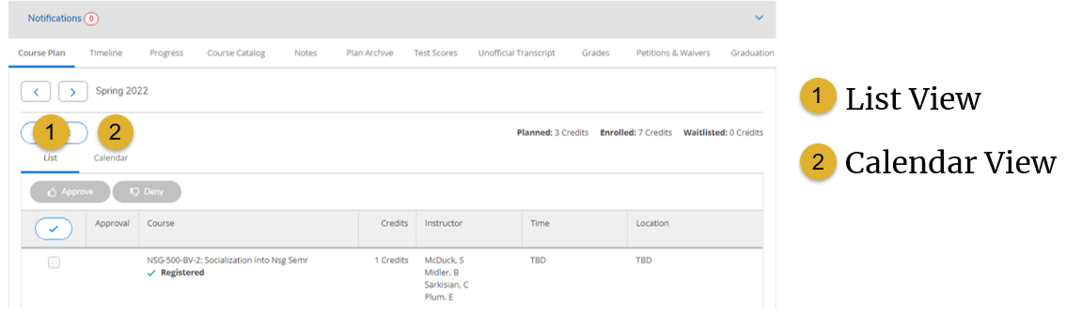
- The timeline allows advisors to view students’ past, enrolled, and planned courses by term. Completed courses appear in light grey. Terms with graded courses will show the grade. Planned courses are shown in dark grey. Pre or corequisites, or courses planned in terms in which they are not typically offered, appear with a yellow warning message.
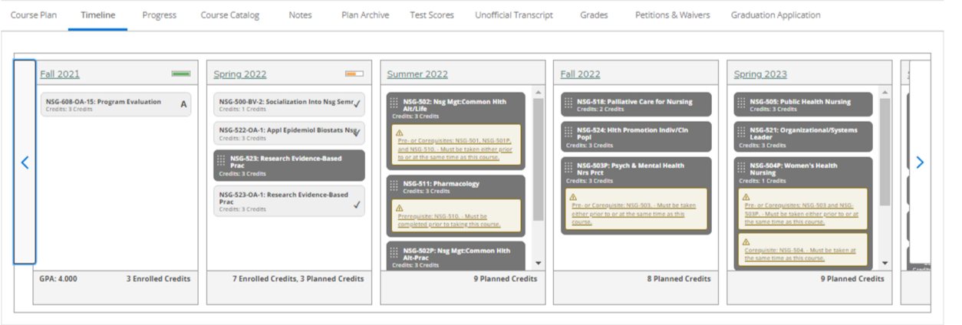
- You may view a student’s degree plan in the Progress tab. If a student is pursuing more than one degree, use the arrow buttons to toggle between degree plans.
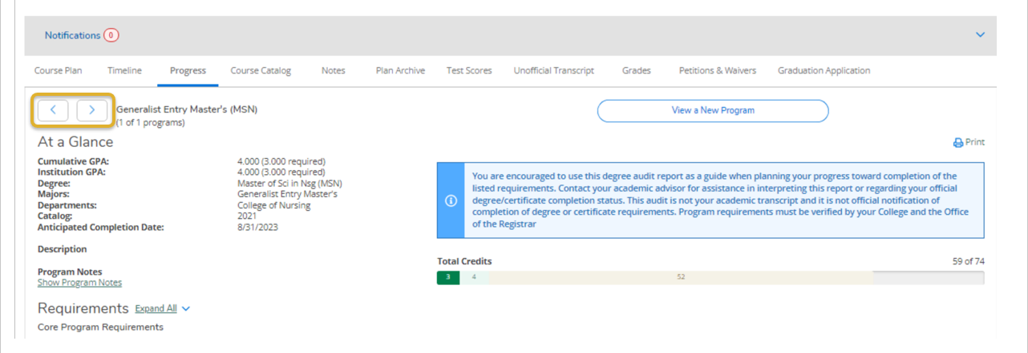
- Progress details show a student’s program requirements by course status (1) such as planned, in-progress, or completed, a grade (2), if assigned, term (3), and course credits (4).
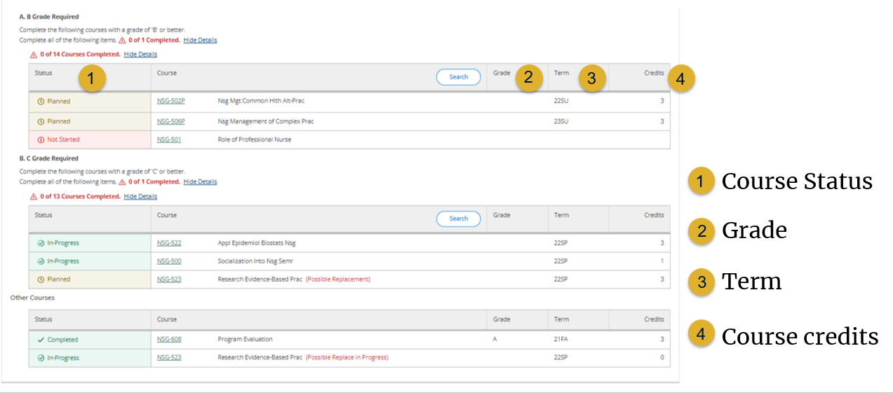

- The Notes feature provides a means of communicating and documenting communications with advisees. Note History cannot be deleted and your advisee will be able to view the communications in Notes. Student Planning will send an automated email communication to the student or advisor, as appropriate, if a note is left in Student Planning. In addition, administrators with access to view all student records will be able to see the text of any notes listed here. For more confidential communications, please use the Rush University email system.

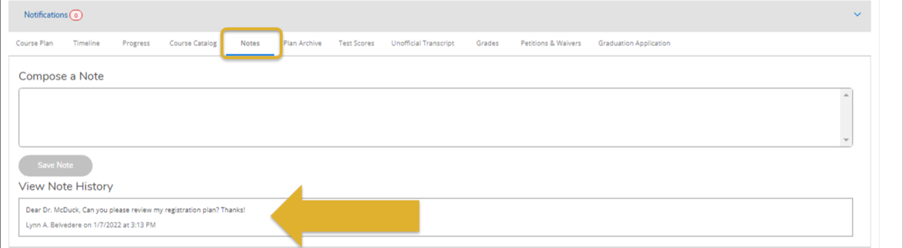

- You may review a PDF of previously archived plans by selecting the Plan Archive tab.
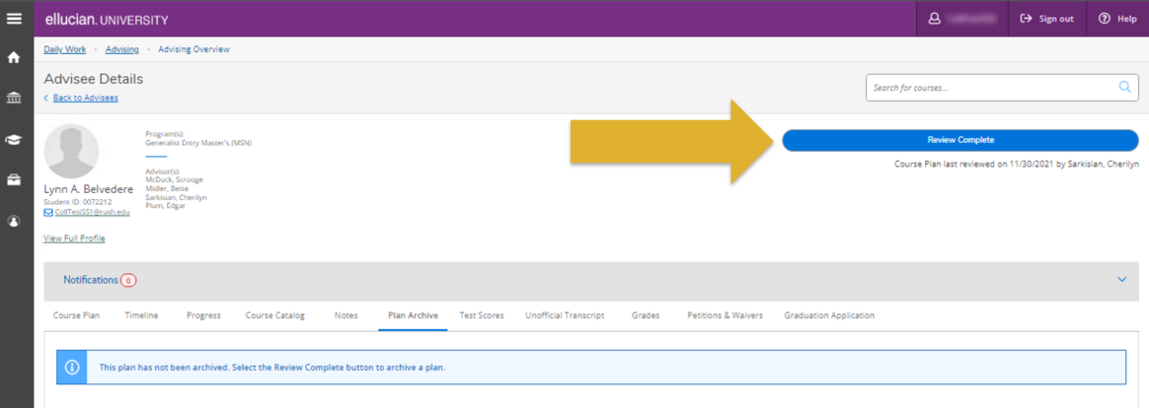

- View an unofficial transcript by selecting the Unofficial transcript tab. Select “Unofficial Transcript” to download a copy of the student’s transcript.

- The grades tab shows a student’s final grade and GPA, listed by term.
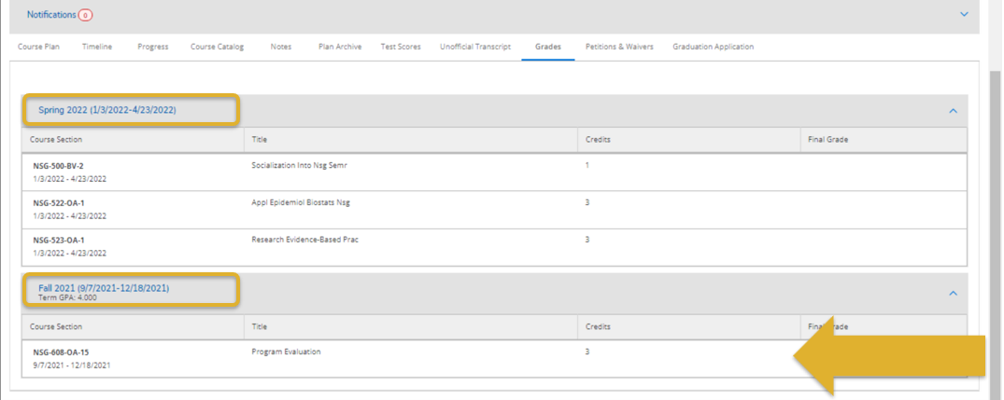
- Student petitions, faculty consents, and waivers are visible in the Petitions and Waivers tab.

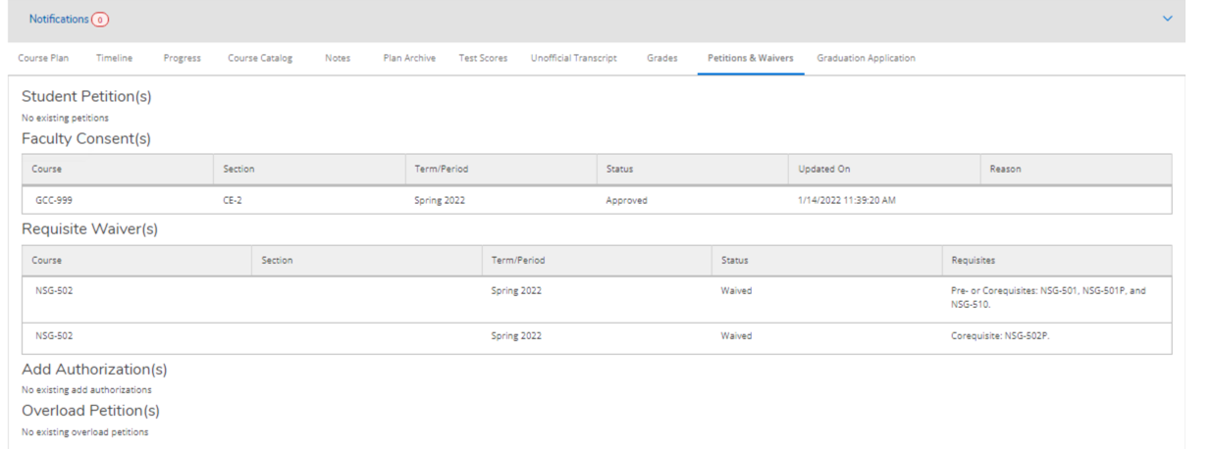

- The Graduation Application allows advisors to review if a student has submitted their Intent to Graduate form. Advisees who have applied to graduate will have a green checkmark and a record of the date of their application notated.
