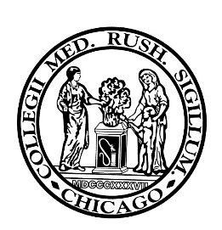 | Global and Community Medicine Elective:  Student Proposal Form  Proposals must be approved at least 4 weeks in advance
This proposal form must be approved by the Course Director (CD), Mariam Aziz, MD, at least 4 weeks prior to the beginning of the elective. Only approved proposals will lead to academic credit for the elective. Submit completed forms to Mariam_Aziz@rush.edu.

Students must have a faculty sponsor at Rush as well as a physician at the site responsible for supervision of the student’s work. Students must complete the on-line global and community health curriculum prior to departure for their work in the community and must submit a completed project within 1 week of the completion of the elective.

Students will be evaluated by the physician supervising the student’s work in the community (using the usual Rush evaluation form or clinical rotations) as well as by the student’s sponsor here at Rush. Student performance in the elective will be graded by the CD as Honor, High pass, Pass, or Fail on the usual Rush course director grade reporting form.

Proposal

Date:

Name of Student:
Email address:
Mobile phone #:

Name of Sponsor:
Sponsoring faculty must have a Rush University faculty appointment.
Email address:
Office phone #:
Sponsor’s Department at Rush:

Name of on-site supervising physician:
Degree obtained:
Name of medical school:
Location of medical school:
Email address:

- Brief narrative description of the proposed experience:

- Proposed distribution of the student’s time on the elective (clinic, lecture, research, etc.) including a daily schedule (additional documents may be attached):

- How will clinical experiences be reviewed by the supervising physician?

- Describe the proposed project to present as a summary of the learning experience of this elective. The project must indicate how the student accomplished the objectives.

Required Signatures

Student:

Rush Sponsor:

Course Director:

Please submit a copy of the approved to Mariam Aziz.

